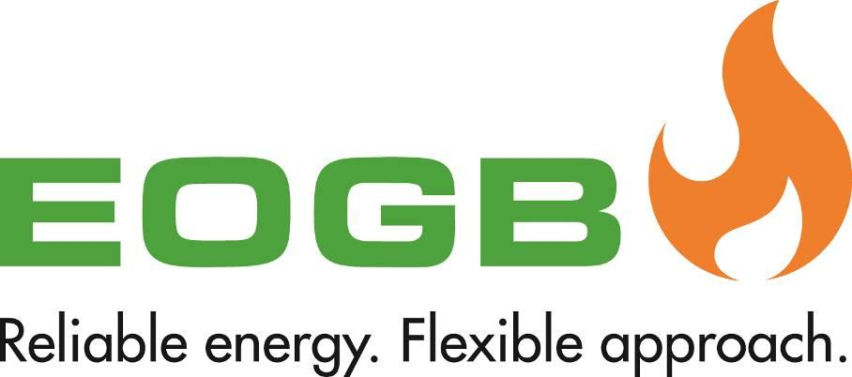

EOGB Nozzle Calculator App - Android Bug
31 October 2019

It has been brought to our attention that there is a bug in the Android version of the EOGB Nozzle Calculator App, which causes an incorrect nozzle size to be displayed under certain user inputs.
The bug occurs then the user changes Nozzle Spray Pattern types and it prompted with an option to “Reset Manually”. If the user selects “Reset Manually”, then the issue does not occur as the nozzle selection wheel appears and the user can reselect the nozzle size. However, if the user presses “Ok” instead of “Reset Manually” then the App resets both Nozzle Capacity and size but only displays capacity as being reset and not the size.
For example, if the user decides to change from a Delavan A/B spray pattern to a Delavan W type, and when prompted to “Reset Manually” the user presses “Ok, then the app will reset the nozzle capacity back to 1.20 kg/h but should display the nozzle size as 0.40GPH. However, the app, at present, displays whatever nozzle size was last selected before switching the new Spray Pattern type - potentially advising the user an incorrect nozzle size.
EOGB are now fully aware of this issue and will update the app as soon as possible. In the meantime, we ask our Android app users to select “Reset Manually” when prompted and reselect a nozzle size until the app is updated. If you have any further questions, please feel free to get in touch with our team on 01480 477066.

